Elephant Hill Fire: Douglas-fir Drought Sensitivity
A drought sensitivity map was generated based on BEC subzone/variant and site series combined with the fire severity map for the Elephant Hill Fire. The following text provides information on the GIS layers used to generate the map and how the calculations were derived to generate the final maps – one showing drought severity risk across the Elephant Hill area based on site series mapping and the other showing the drought severity risk based on a combination of site series mapping and fire severity mapping for the Elephant Hill fire. The former map provides an indication of drought sensitivity based on the removal of the forest canopy whereas the latter provides an indication of drought sensitivity as it currently exists on the landscape assuming that with increasing fire severity there is a loss of forest canopy structure so that severely burned sites have site conditions similar to those found in clearcuts.

GIS Layers Used to Generate Maps
Three GIS layers were used to generate Elephant Hill Douglas-fir drought sensitivity maps.
- A predictive ecosystem map (PEM) was completed in 2008 for the entire Cariboo Forest Region and is used as the basis for identifying site series across the landscape for the Cariboo portion of the Elephant Hill Fire. Unlike BEC maps, PEMs identify individual site series or ecosystem types across the landscape. Although, these maps are unsuitable at a site level to predict specific site series at a given point on the landscape because they cannot necessarily predict the identification of site series with a high degree of accuracy, they are useful at a landscape level to identify general areas where site series within a BEC subzone or variant are likely to occur including those where Douglas-fir may be sensitive to drought resulting in damage or death to Douglas-fir seedlings and young regen. A copy of the Cariboo PEM Final Report can be downloaded at the following link:
http://www.env.gov.bc.ca/esd/distdata/ecosystems/wis/pem/warehouse/region_5_Cariboo/Cariboo_ftp_final_5512/pem_5512_rpt.pdf

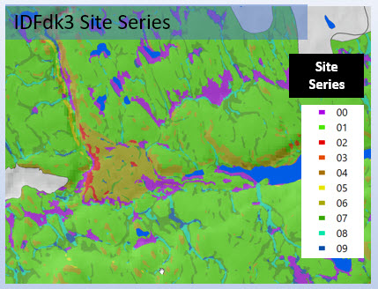
Figure 1. Portion of the Cariboo PEM for the IDFdk3 showing the distribution of site series across the landscape.

- A draft preliminary PEM of the Kamloops Timber Supply Area that encompasses the southern portion of the Elephant Hill Fire was used to identify site series and ecosystem types. Unlike the Cariboo PEM, the Kamloops map is a draft product undergoing a review and has not yet been tested for accuracy.

- GISolutions created a fire severity map of the Elephant Hill Fire based on a comparison of Landsat 8 OLI imagery before and after the fire. However, the northern portion of the map was completed before the end of the fire and is therefore not accurate. It shows a significant area of unburned area that, in fact, burned.

ArcGIS files
The ArcGIS shapefile “MERGE_FdFrostFire6” contains the data and fields used to generate two maps related to Douglas-fir drought sensitivity within the perimeter of the Elephant Hill fire.
The fields relevant to these maps include:
BGC_Label – BEC subzone or variant label
SiteSeries – identified BEC site series based on the classification in the of “A Field Guide to Forest Site Identification and Interpretation for the Cariboo Forest Region Land Management Handbook Number 39” (Steen and Coupé, 1997) and a updated draft classification for BEC site series within the Kamloops TSA
OldSiteSer – crosswalks the draft BEC classification for the Kamloops portion of the map to those identified in the published BEC classification for the Kamloops region described in “A Guide to Site Identification and Interpretation for the Kamloops Forest Region Land Management Handbook 23 (Lloyd et al. 1990). The site series for the Cariboo Region are the same as those identified in the field “Site Series” based on LMH Handbook No. 39.
SiteSens – Drought sensitivity score for a given polygon based on identified BEC site series. This field was used to create the map for Douglas-fir Drought Sensitivity map based on site series.
BurnSev – identifies burn severity based on categories: unburned, Low, Medium, and High
BURNCODE – numeric codes matching BurnSev catgories: 1 – unburned, 2 – Low, 3 – Medium, 4 – High
BS_SS – Multiplication of the Site Series drought sensitivity score (SiteSens field) and the fire severity code (BURNCODE field).
BS_SS_Leg – Coding of the BS_SS score based on the BS_SS code and the BGC unit in which it occurs. The Drier and warmer BGC units (e.g. IDFxh2, IDFxw) are more likely to incur drought conditions than cooler or wetter BGC units (e.g. IDFdk1, IDFdk3). Hence, the assignment of the BS_SS score changes across BGC units so that the same score in a cooler/moister BGC unit is considered less drought sensitive than the same score in a drier/warmer BGC unit. See the spreadsheet “ranking of site series by burn sensitivity.xlsx” for the colour coding of BS_SS scores by BGC unit. This field was used to generate the map for Douglas-fir Drought Sensitivity map based on Site Series and fire severity.

Development of Douglas-fir Drought Ratings
Drought ratings were developed for each site series within each BEC subzone and variant. Information for BEC subzones and variants based in the Cariboo Region are based on silvicultural considerations outlined in Chapter 7 of “A Field Guide to Forest Site Identification and Interpretation for the Cariboo Forest Region Land Management Handbook Number 39” (Steen and Coupé, 1997). Those for BEC subzones and variants within the Kamloops TSA are based on a review of draft stocking standards and draft BEC descriptions currently under development for the Thompson-Okanagan Region. The provided Excel file provides the drought rating scores for BEC subzones and variants within the Elephant Hill fire. These scores are based on the likelihood of frost damage to Douglas-fir occurring following the removal of the overstorey vegetation (typically following clearcut logging). The sensitivity score for Douglas-fir is shown below (Table 1). Non-forested areas lack Douglas-fir and are scored a value of “0”. Conifer-dominated areas are ranked from low (1), medium (2), and high (3) in terms of risk to drought conditions.
Table 1. Drought scores related to Douglas-fir applied to each site series
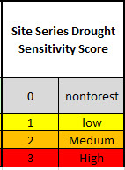
Scores for all site series within the Elephant Hill Fire are identified in the attached Excel file – “ranking of site series by burn sensitivity.xlsx” of which a portion is shown below for a portion of the BGxh2, BGxw1 and ESSFxc2.
Table 2. Drought Sensitivity scores assigned to each site series within the Elephant Hill area. 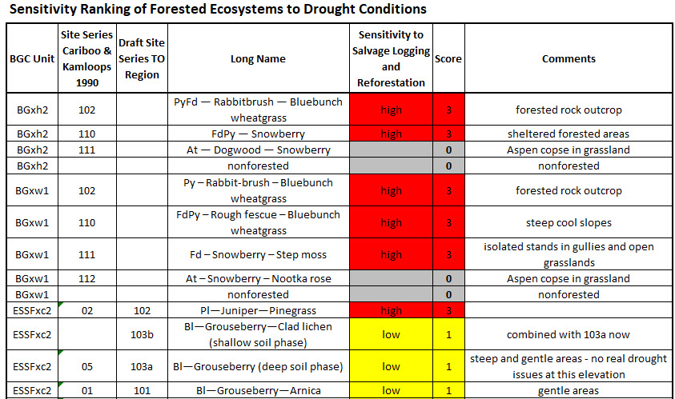
Once the Sensitivity Ranking of forested site series to drought was completed, the scores were applied to the Elephant Hill area based on site series to generate a final pdf map product showing the sensitivity ranking of forested site series to drought conditions for Douglas-fir.
These scores were completed independent of the Elephant Hill burn severity map and reflect the sensitivity of the site series to drought following the removal of the forest canopy.
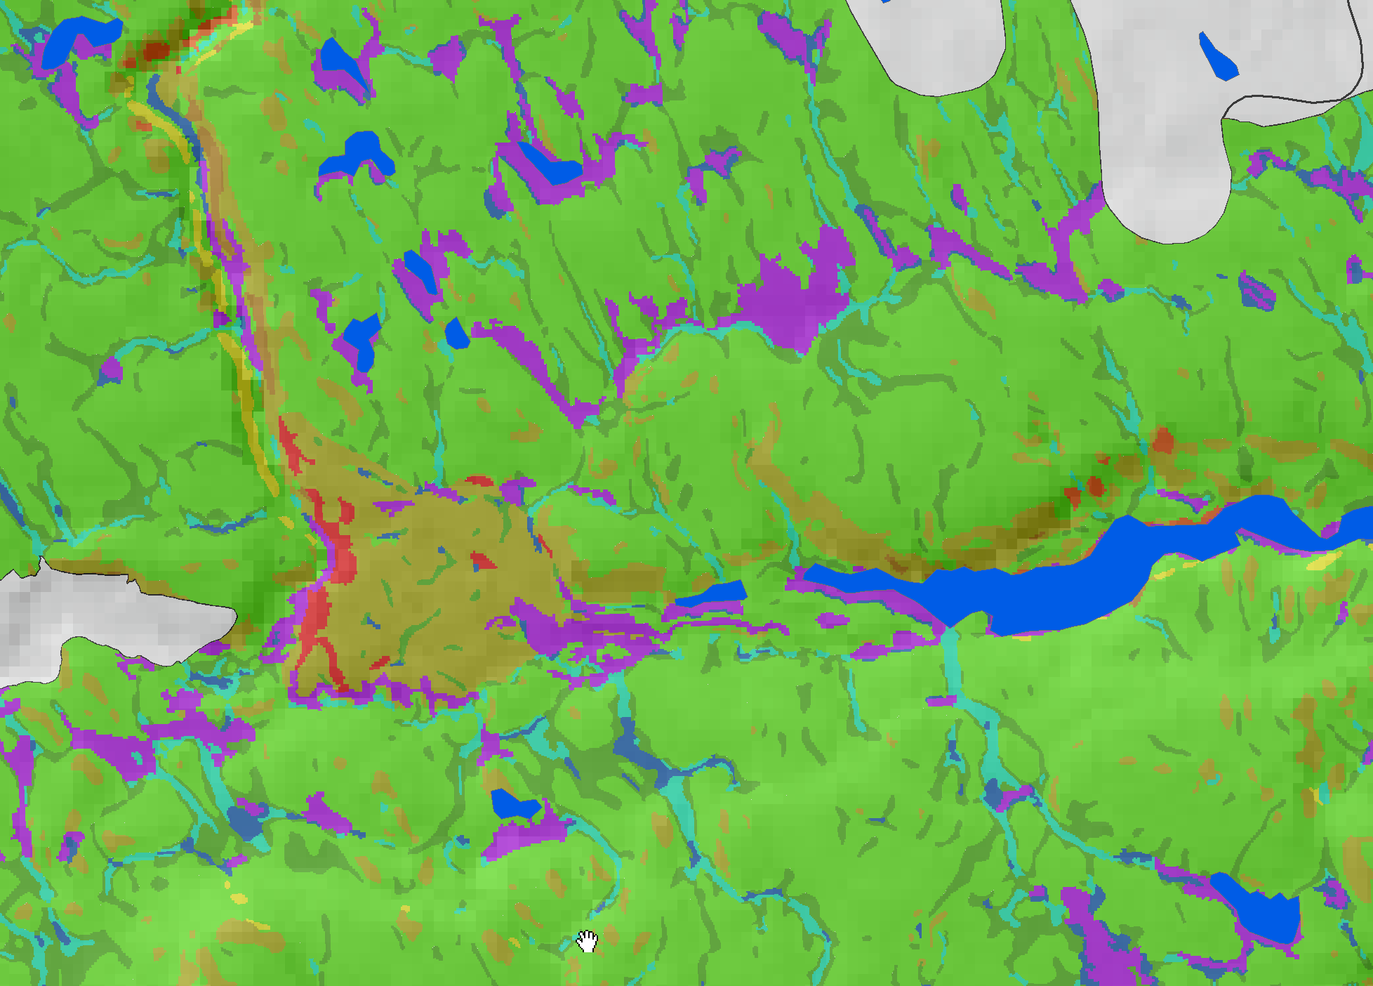
Figure 2. Portion of the PEM showing mapped site series. Green identify mesic sites, browns and reds identify dry sites sand blues and purples identify moist and wet site series.
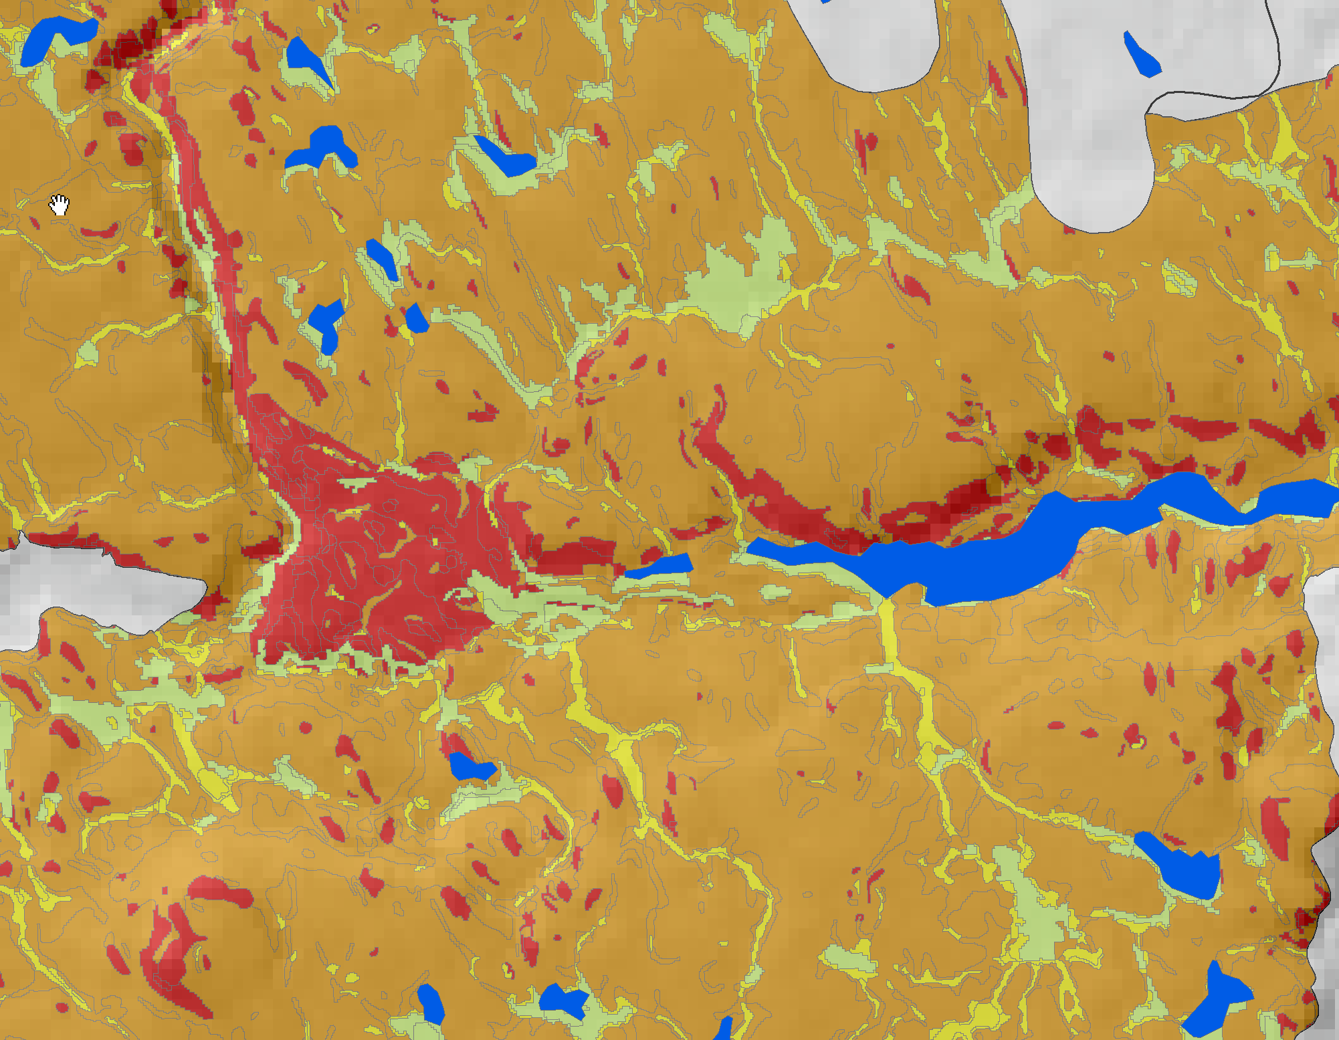
Figure 3 Portion of the PEM map shown in Figure 2 remapped to indicate Douglas-fir drought sensitivity based on the scores assigned to individual site series. Yellow areas represent site series that have low drought risk for Douglas-fir, orange medium drought risk and red high drought risk. Light green areas are non-forested areas.

. 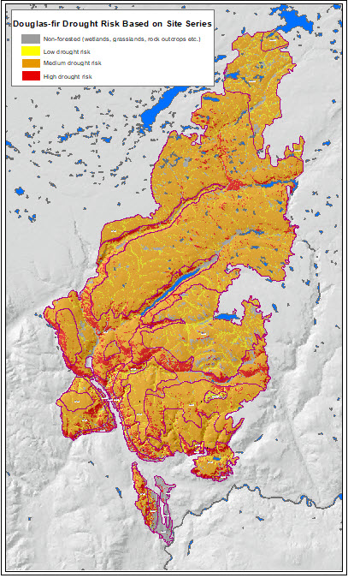
Figure 4. Completed map of Douglas-fir drought risk for the Elephant Hill fire based on site series.

Development of Douglas-fir Drought Ratings in Conjunction with the Elephant Hill Fire
Drought ratings of Douglas-fir were also developed in conjunction with the fire severity map where the score of the site series based on drought sensitivity was multiplied by the burn severity score at the mapped location.
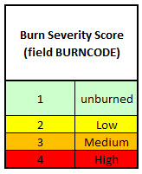

These combined drought sensitivity and burn severity scores reflect the current drought risk associated with the site before any post-fire activities have been initiated. Hence, sites which likely retain some canopy cover that would include unburned, low and medium severity burn areas remain less drought-prone than high severity burn areas where much or all of the canopy has been destroyed. The colour-coding of these combined scores have been adjusted depending on the overall climate conditions associated with the BGC unit so that the same score in the BG, PP or IDFxh2 units is more drought sensitive than that of a cooler or wetter BGC unit. A complete list showing the coding for each BGC unit used to generate the map are located in the attached Excel file – “ranking of site series by burn sensitivity.xlsx” in columns O, P and Q.
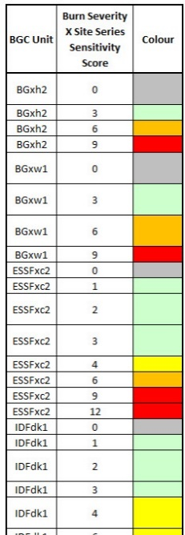
5.A portion of the colour coding assigned to the combined site series and burn severity score for each BGC unit.
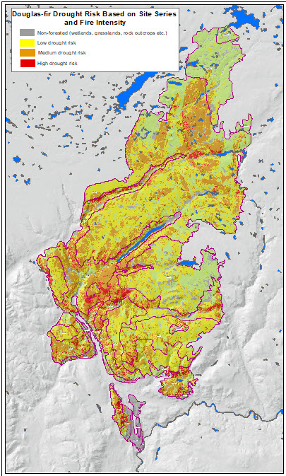
Figure 6. Drought risk for Douglas-fir based on site series and fire severity. Areas in red reflect areas that are most likely to incur drought conditions. Note dry forested areas in warm and dry BGC units such as the IDFxh2 and IDFxm are more sensitive to drought conditions than BGC units in cooler or wetter climates such as the IDFdk3, MSxk2 or SBPSmk.
References
Lloyd, D., K. Angove, G. Hope, and C. Thompson. 1990. A guide to site identification and interpretation for the Kamloops Forest Region. B.C. Min. For., Victoria, B.C. Land Manage. Handb. No. 23.

Steen, O. A. and R. A. Coupé. 1997. A field guide to forest site identification and interpretation for the Cariboo Forest Region. BC. Min. For., Victoria, B.C. Land Manage. Handb. No. 39.

